Final Project Part 1

Connor Medeiros

IT-230

Professor Johnathan Norman

Southern New Hampshire University

Aug 2025

Main Menu & First Course Selection

A. Screenshot when the menu first displays, and the student registers for the first course.

B. Description: Main menu with first course selected and registered.

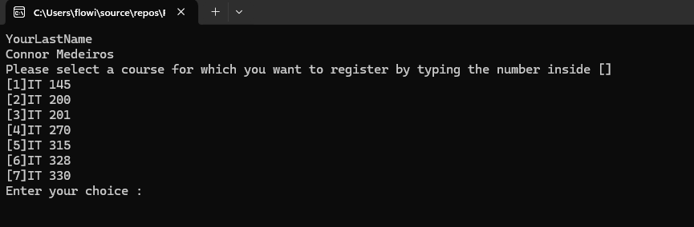

**Duplicate Course Attempt**

1. Screenshot, when the student tries to register a course number that does not exist.
2. Description: Shows error message when attempting to register for a course that is not listed.

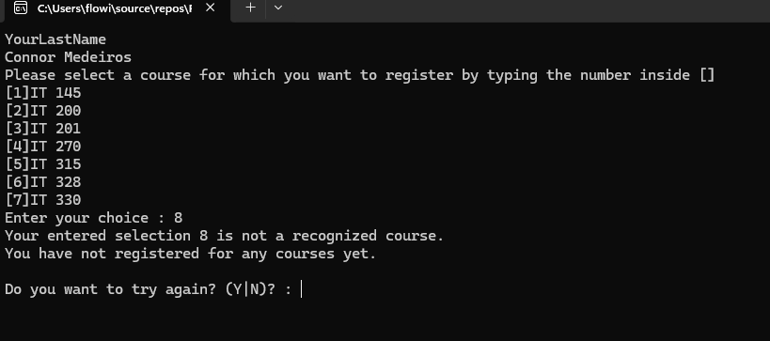

1. Screenshot, when student tries to register for the same course twice
2. Description: shows message stating that the user has already registered for the class.

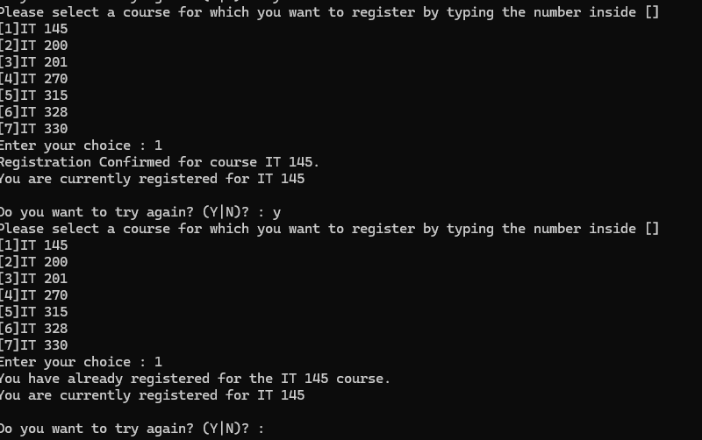

1. Screenshot, student tries to apply for classes that exceed the max credit hours
2. Description, a rejection message is displayed stating that that entry exceeds the max credit hours registered

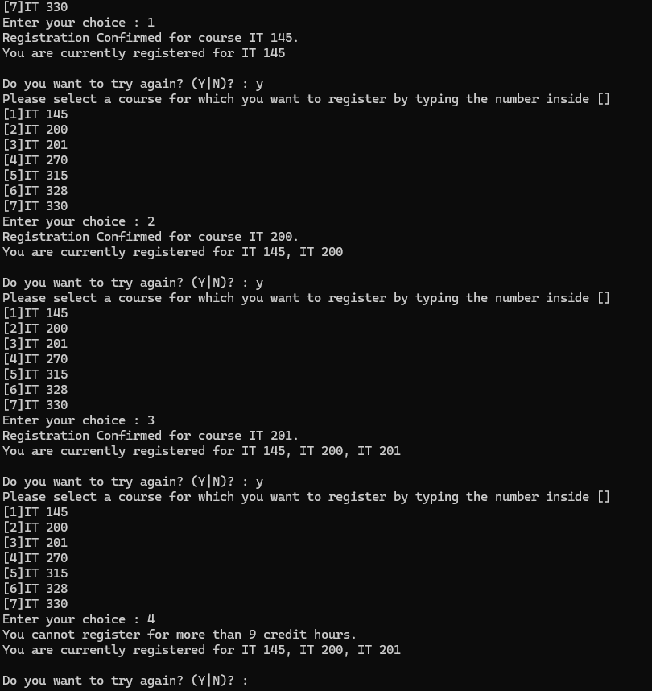

1. Screenshot, user typing “n” to exit the program and complete registration
2. Description, user receives message stating “thank you for registering with us”

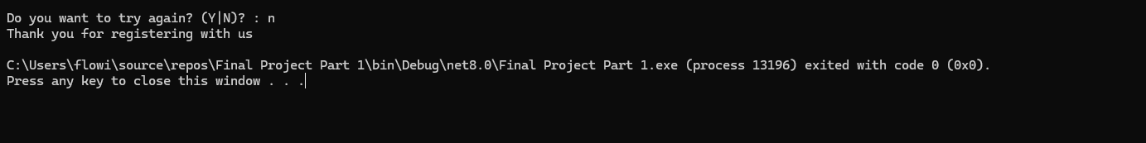

Source Code:

using System;

using System.Collections.Generic;

using System.Linq;

using System.Text;

using System.Threading.Tasks;

namespace ConsoleRegisterStudent

{

class Program

{

static void Main(string[] args)

{

(new Program()).run();

}

void run()

{

int choice;

int firstChoice = 0, secondChoice = 0, thirdChoice = 0;

int totalCredit = 0;

string yesOrNo = "";

Console.WriteLine("YourLastName"); // Replace with your last name

Console.WriteLine("Connor Medeiros");

do

{

WritePrompt();

choice = Convert.ToInt32(Console.ReadLine());

switch (ValidateChoice(choice, firstChoice, secondChoice, thirdChoice, totalCredit))

{

case -1:

Console.WriteLine("Your entered selection {0} is not a recognized course.", choice);

break;

case -2:

Console.WriteLine("You have already registered for the {0} course.", ChoiceToCourse(choice));

break;

case -3:

Console.WriteLine("You cannot register for more than 9 credit hours.");

break;

case 0:

Console.WriteLine("Registration Confirmed for course {0}.", ChoiceToCourse(choice));

totalCredit += 3;

if (firstChoice == 0)

firstChoice = choice;

else if (secondChoice == 0)

secondChoice = choice;

else if (thirdChoice == 0)

thirdChoice = choice;

break;

}

WriteCurrentRegistration(firstChoice, secondChoice, thirdChoice);

Console.Write("\nDo you want to try again? (Y|N)? : ");

yesOrNo = (Console.ReadLine()).ToUpper();

} while (yesOrNo == "Y");

Console.WriteLine("Thank you for registering with us");

}

void WritePrompt()

{

Console.WriteLine("Please select a course for which you want to register by typing the number inside []");

Console.WriteLine("[1]IT 145\n[2]IT 200\n[3]IT 201\n[4]IT 270\n[5]IT 315\n[6]IT 328\n[7]IT 330");

Console.Write("Enter your choice : ");

}

int ValidateChoice(int choice, int firstChoice, int secondChoice, int thirdChoice, int totalCredit)

{

if (choice < 1 || choice > 7)

return -1;

else if (choice == firstChoice || choice == secondChoice || choice == thirdChoice)

return -2;

else if (totalCredit >= 9)

return -3;

return 0;

}

void WriteCurrentRegistration(int firstChoice, int secondChoice, int thirdChoice)

{

if (firstChoice == 0)

Console.WriteLine("You have not registered for any courses yet.");

else if (secondChoice == 0)

Console.WriteLine("You are currently registered for {0}", ChoiceToCourse(firstChoice));

else if (thirdChoice == 0)

Console.WriteLine("You are currently registered for {0}, {1}", ChoiceToCourse(firstChoice), ChoiceToCourse(secondChoice));

else

Console.WriteLine("You are currently registered for {0}, {1}, {2}", ChoiceToCourse(firstChoice), ChoiceToCourse(secondChoice), ChoiceToCourse(thirdChoice));

}

string ChoiceToCourse(int choice)

{

string course = "";

switch (choice)

{

case 1: course = "IT 145"; break;

case 2: course = "IT 200"; break;

case 3: course = "IT 201"; break;

case 4: course = "IT 270"; break;

case 5: course = "IT 315"; break;

case 6: course = "IT 328"; break;

case 7: course = "IT 330"; break;

default: break;

}

return course;

}

}

}